Making Conductive Dough

Subject:  Related Subjects: | Grade Level(s):  Length of Lesson: | Type: Inquiry / Design / Project  Keywords:

Lesson Overview
Use this section to describe at a high level what the lesson is. Should be no more than 3-4 lines.

Lesson Focus
What is the central question or phenomenon being investigated? What problem are they trying to solve?

Lesson Objective(s) | By the end of this lesson, students will…  - Learn the concepts of attraction, repulsion, friction, polarity, and charge.

Lesson Timing

5 minutes | Introduce the Lesson
30 minutes | ...

Materials | 1 cup Water  1 1/2 cups Flour  1/4 cup Salt  9Tbsp. of Lemon Juice may be Substituted  1 Tbsp. Vegetable Oil  Food Coloring (optional)
Instructor Prep | - Step 1
Related Resources | - List related lessons/ppts etc available from USC or outside, trusted orgs

Lesson Plan

Introduction
Introduce students to the learning goals and make connections to past and present learning experiences. Stimulate interest and prompt students to identify their own questions about the topic. This can link the lesson to real world examples, introduce associated STEM careers, and assess their prior knowledge on the topic.

- Step 1

Procedure
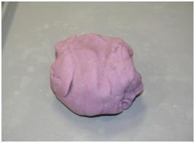
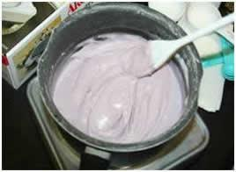
Mix water, 1cup of flour, salt, cream of tartar, vegetable oil, and food coloring in a medium sized pot.

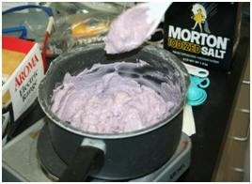2. Cook over medium heat and stir continuously.
3. The mixture will begin to boil and start to get chunky.

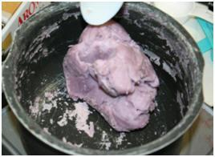4. Keep stirring the mixture until it forms a ball in the center of the pot.

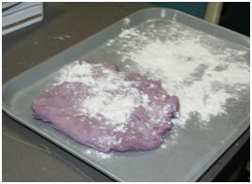5. Once a ball forms, place the ball on a lightly floured surface.
WARNING: The ball will be very hot. We suggest flattening it out and letting it cool for a couple minutes before handling.

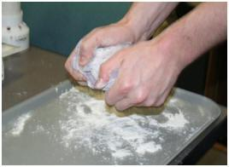6. Slowly knead the remaining flour into the ball until you’ve reached a desired consistency.

7. Store in an airtight container or plastic bag. While in the bag, water from the dough will create condensation. This is normal. Just knead the dough after removing it from the bag, and it will be as good as new. If stored properly, the dough should keep for several weeks.

Wrap-up
End the lesson with some final discussions about what students designed/discovered. Connect their activity back to the focus question/problem, real world examples, and STEM careers.

Also include notes about any special cleanup considerations

Lesson Background for Teachers

Suggested Real-World STEM Connections
- List possible related Role Models in STEM (with details and links to more reading). Give suggestions for examples of scientists/engineers who are from underrepresented groups in STEM in related careers.
- List related real-world engineering problems and examples

Lesson Variations and Options
Include descriptions of alternative methods or ways to present things.

Explanation
Describe the background concepts and explanations behind the lesson. This can be more in depth than a teacher/instructor would actually share with students.

Key Concepts and Vocabulary
- Word 1: Grade Appropriate Definition
- Word 2: Grade Appropriate Definition

Safety Notes
- Safety instruction

